**Overview**

Student - User should be able to navigate through the home page and enter data on the account page once registration has been completed and logged in. User will have access to all pages including semester, class and data updates.

Teacher - User should be able to navigate through the home page and enter data on the account page once registration has been completed and logged in. User should be able to edit data from the faculty page to update data from everyday activities.

Employer - User should be able to navigate through the home page and enter data on the account page once registration has been completed and logged in. User should be allowed only to view data and search for candidates with the correct information that has been provided by the student and teacher.

**Backend Service**

The backend service for my SHADOW Web APP will be built using node.js library. The frontend data will be created by the user with REST API programming interface. Simple data will only be entered such as text, comments, user input and data manipulation. Therefore, the user interface between each user will include the following:

1. Client server architecture – As long as the user is connected to the internet, each user will be able to access their info or page. REST API will be able to GET, POST, PUT and DELETE information on the server as long as user is signed in.
2. Cloud Computing – Any external information that can be downloaded or extracted can be saved through the cloud. Depending on data type and file size, users will be able access this information as long as connected.
3. Database – PostgresSQL will be the main storage for all data inputs, this includes personal information and data manipulation.

**User Interface**

Routing of the service endpoints will be explained by the following information with Heroku:

1. Post: Registration

Method: Post

URL: https://shadow691.herokuapp.com/login

Purpose: When a user wants to sign up, the user is prompted to enter the information in order to register for the app. They will have to enter their information and include their personal in order to help secure their account. Including Username, Password and email. If any inputs that is entered incorrectly, user will be prompted with an error message.

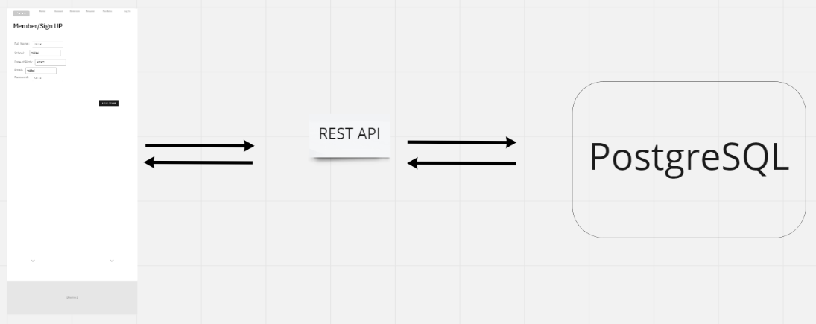

Example:

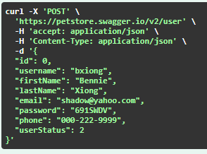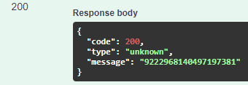

1. Get Account:

Method: GET

URL: https://shadow691.herokuapp.com/login/account

Purpose: When a user logs in, the user is able to access the account info. All their information will be accessible and interchangeable when they are able to login into the app. They will have access according to their registration and where they categorize themselves as student, faculty or employer.

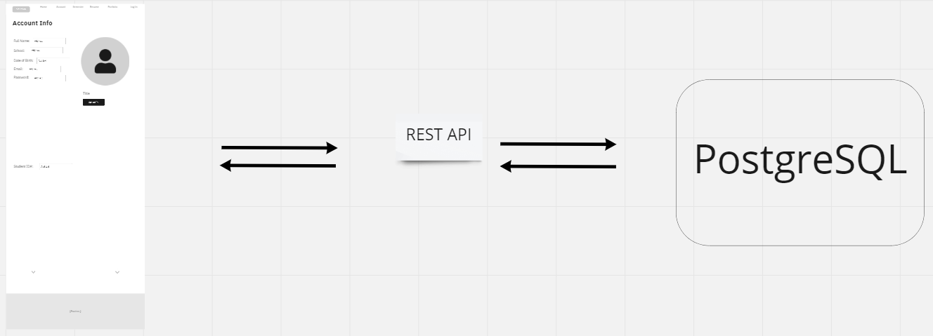

Example request:

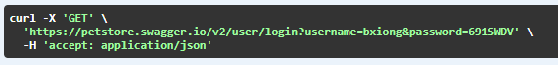

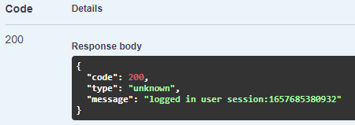

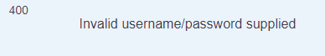

1. Post Picture:

Method: Post

URL: https://shadow691.herokuapp.com/account/pic

Purpose: When a user logs in, the user is allowed to upload pic from their own local files. This will make them have a recognizable image from the school in order to validate their identity at school. Faculties and Employers will also have the chance for them to upload their picture.



Example:

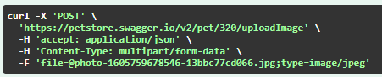

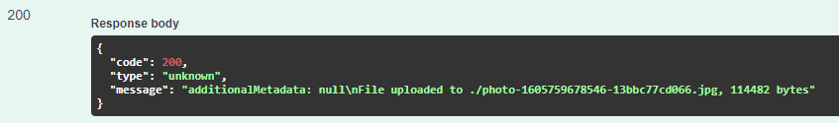

1. DELETE Picture:

Method: DELETE

URL: https://shadow691.herokuapp.com/account/pic

Purpose: Users will be able to delete the picture that was uploaded previously. All pictures are not final but is recommended to have a current picture for verification purposes.

1. Get Term, Year, ID#:

Method: GET

URL: https://shadow691.herokuapp.com/term/year/id

Purpose: When a user logs in, the user is prompted to enter the term, year and id# in order to access the page. This will users to access the current semester including previous semesters as well.

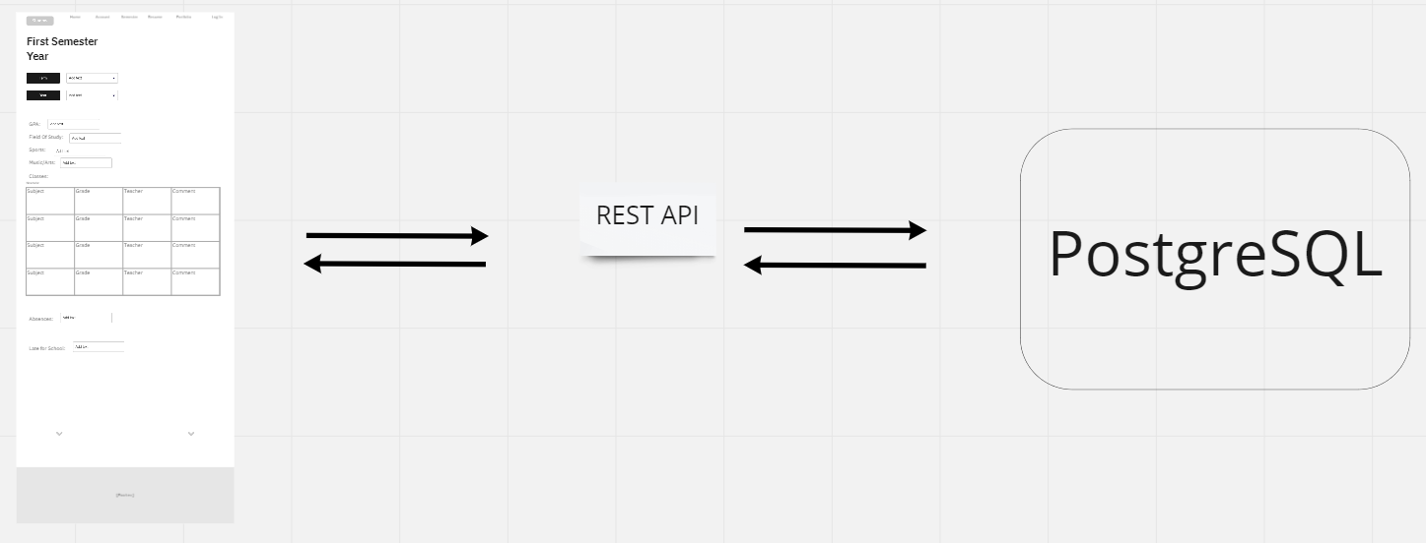

Example:

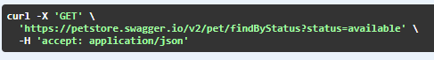

 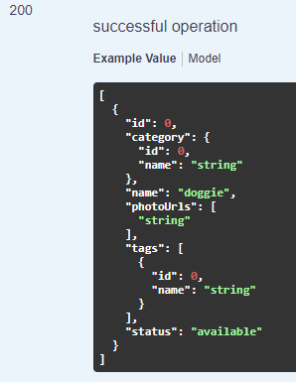

1. Get Course:

Method: GET

URL: https://shadow691.herokuapp.com/course

Purpose: When a user logs in, the user is able to update the classes accordingly. Faculty staff and employers will be allowed to have different access and availability when signed in. This helps the users able to view others who are academically inclined.



Example:

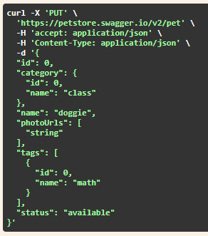 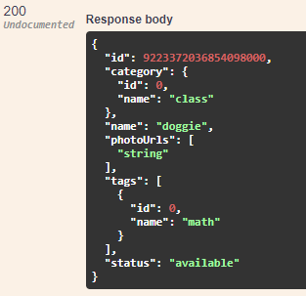 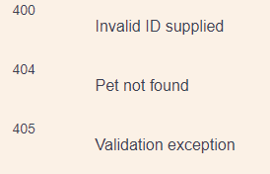

1. Post resume:

Method: Post

URL: https://shadow691.herokuapp.com/resume

Purpose: When a user logs in, they are able to access the resume information and transfer their previous info into the resume slots. This will help post their information faster and much more accurately for viewers to see in a slotted format including with manual entries that will be updated when ready to view and downloaded.

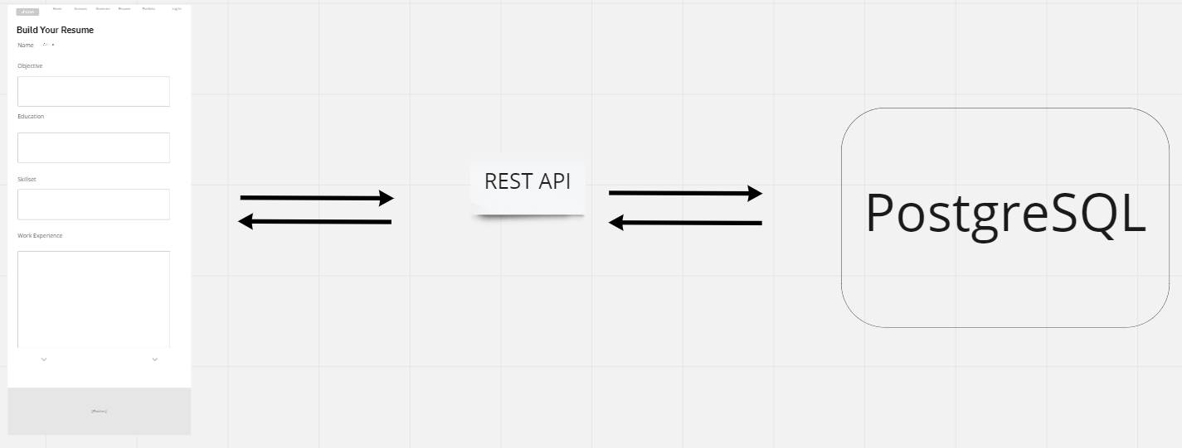

Example:

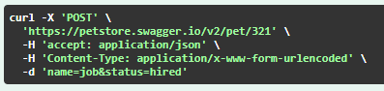

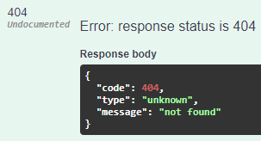

1. Post Portfolio:

Method: Post

URL: https://shadow691.herokuapp.com/portfolio

Purpose: When a user logs in, they are able to access the resume information and transfer their previous info into the resume slots. This will help post their information faster and much more accurately for viewers to see in a slotted format including with manual entries that will be updated when ready to view and downloaded.

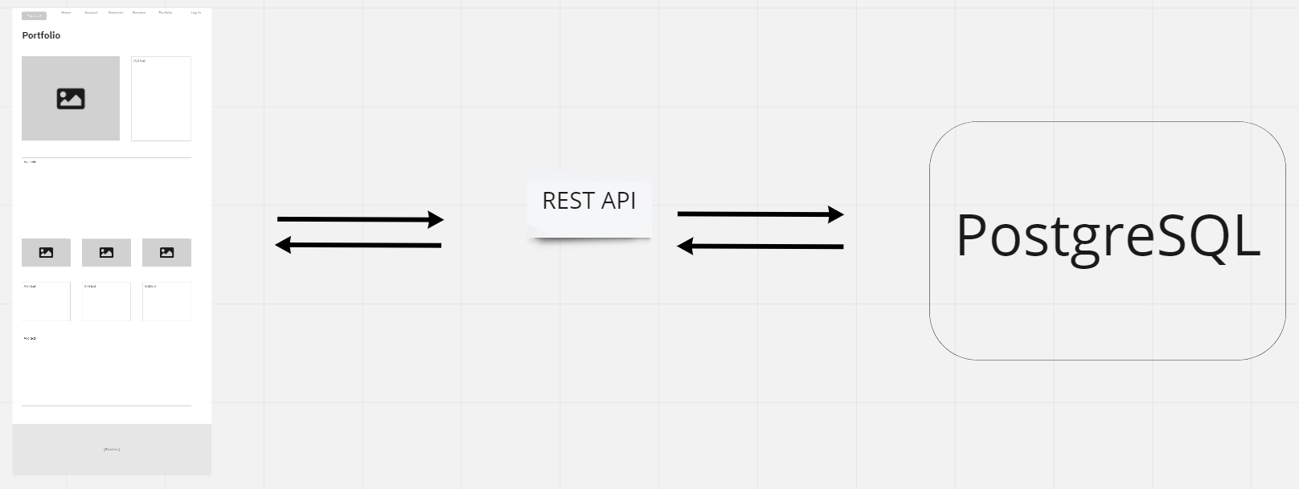

Example:





1. Delete Resume:

Method: DELETE

URL: https://shadow691.herokuapp.com/resume

Purpose: When a user logs in, they are able to delete the existing resume and create a new resume. This will help clean and organize their files and make it organized instead of having multiple files on record.



Example:

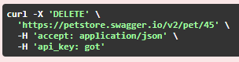

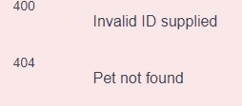

1. Delete Portfolio:

Method: DELETE

URL: https://shadow691.herokuapp.com/portfolio

Purpose: When a user logs in, they are able to delete the existing resume and create a new resume. This will help clean and organize their files and make it organized instead of having multiple files on record.



Example:



